Table of Contents
- Identifying the problem related to the chosen potential application 2
1.0 Introduction 2
1.1 Investigating current systems 3

2) Proposed Solution 12
2.0 Problem Statement 12
2.1 Proposed IoT Solution 12
2.1.0 Concept Overview 12
2.1.1 Implementation and Entrepreneurial Impact 12
2.1.2 System Architecture Diagram 13
2.1.3 Industry Application 15
2.1.4 Unique Value Proposition 15
2.1.5 Scope of the System 15
2.1.6 Functional and Non-Functional Requirements 16
3) Conclusion 18
4) Video Pitch 18
5) Reference List 18

- Identifying the problem related to the chosen potential application

- Introduction

Metaverse is a 3D virtual world where people can escape reality by using specialized equipment, such as a VR headset. It uses augmented and virtual reality to let users blur the line between the real and virtual worlds. It is a whole new era of the internet; people can browse without having to sit in front of a screen. One can do so much with it, and it's human imagination that is the only barrier. You can watch movies, play games with other users, or have more realistic and engaging conversations.

The relationship between IoT and Metaverse may be crystal clear now, as mapping data from the real world into virtual reality is the big problem of Metaverse. The data should be accurate, organized, significant, secure, and in real time. Hundreds of sensors, cameras, wearables, and other devices are ready to be integrated into Metaverse, even though IoT itself has been in use for many years.

IoT and Metaverse will fuel each other. Already some experts refer to them as "technology twin." With the help of IoT, Metaverse will be able to assess and interface with the real world. At the same time, Metaverse will act as a 3D user interface for IoT devices, providing a unique customized IoT user experience. The world will be able to make data-driven decisions with less training and mental effort due to Metaverse and IoT. The metaverse is a large, extensive platform built from many technologies: digital twins, 5G/6G, AR/MR/VR/XR, IoT, and AI.

One of the biggest difficulties the digital ecosystem faces is how easily new privacy and security risks might come to the fore, especially in the milieu of the metaverse.

Future integration of IoT and the metaverse will come with a variety of opportunities and challenges. Security and privacy concerns turn progressively crucial, while IoT devices and the metaverse become connected and share data. Strict security measures are to be implemented in order to protect sensitive data and avoid unauthorized access, as connectivity of devices and virtual environments opens up a whole new dimension of risks.

The integration of the metaverse and IoT will generate a huge amount of data. It is very challenging to manage and analyze such huge data in real time. To get useful insights and maximize system performance, efficient methods for data processing, storage, and analysis will be needed.

1.1 Investigating current systems

Numerous research papers have been written about improving internet of things security, security in the metaverse, etc.
Integrated cybersecurity for Metaverse systems operating with artificial intelligence, blockchains, and cloud computing is one of the papers that will be examined. It establishes a central "Integrated Cybersecurity" layer that connects the Cloud, Blockchain, Metaverse, and AI domains, using AI as a proactive agent to anticipate threats and utilizing frameworks like MITRE ATT&CK for layered defense (Radanliev, 2024).
The following are the main issues noted in the paper: Current cybersecurity frameworks and standards, such as earlier iterations of NIST and ISO, are more than ten years old and are currently "patched approaches," not entirely intended to handle the particular threats brought forth by these novel, extreme technologies.
To add on, as a "nascent yet rapidly evolving digital Frontier," the Metaverse raises new and complicated security issues, especially with relation to user privacy, data security, misinformation, and asset theft in an infinite digital space.
Finally, Threat actors and vulnerabilities are ever-changing, necessitating ongoing exposure assessment.
The article is a strategic framework of integrated cybersecurity, the research provides a holistic view and recommendations of a strategic path of integrated cybersecurity in the four technological domains (Metaverse, AI, Blockchain, Cloud).
The key finding identifies a need to have proactive regulatory engagement and innovations by policy makers and cybersecurity scholars to keep pace with the rapid evolution of these technologies.
As identified in the paper, the application of blockchain to securing cloud environments is important by exploiting its innate features, including eliminating single point of failure; blockchain is a distributed ledger, so any breach of data will be detected and eliminated, enhancing authentication; a blockchain-based authentication system can be applied to improve security within a cloud setting by taking advantage of its inherent properties, multi-sign; the decentralized nature of data shows that any breaching of information will be addressed and removed, data integrity; by maintaining the originality of information and making transactions unchangeable, distributed ledger technology avoids data breaches.
Using the MITRE ATT&CK framework as a prime example, the article promotes the use of a layered protection strategy in cybersecurity architecture. And highlights the vital role that concepts like Cyber Value at Risk (FAIR Method) and tools like the Software Bill of Materials (SBOM) play in proactively assessing and mitigating possible threats.

The Metaverse Core (shown in blue) is positioned at the center of the ecosystem in figure 1 below. It demonstrates how three essential technologies are used to surround and improve the core in order to achieve integrated cybersecurity.

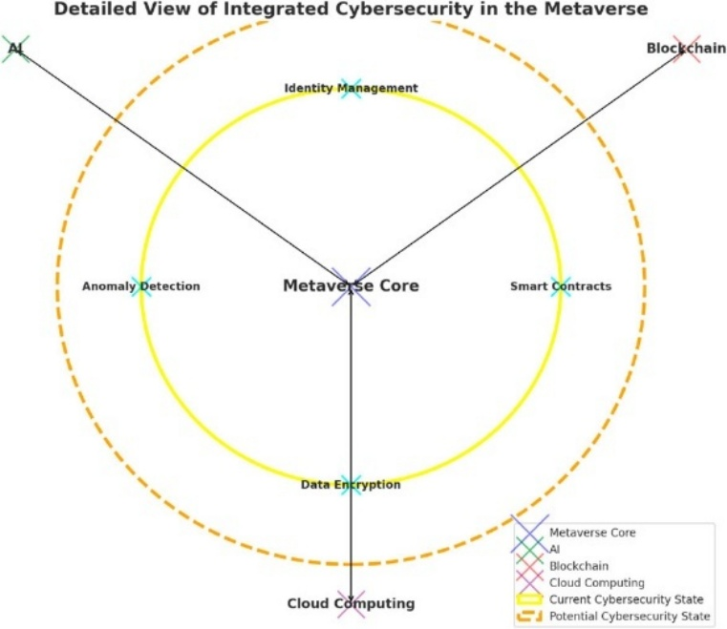

Figure 1. Detailed view of the new integrated cybersecurity in the Metaverse with AI, Blockchain, and Cloud Computing.

- Artificial Intelligence (AI): Used for proactive security, specifically anomaly detection.
- Blockchain: Provides decentralized trust and it is associated with such features as smart contracts and asset/identity management.
- Cloud Computing: Signifies the data storage and computing infrastructure that is further increased with additional attributes such as data encryption.

Important Security Features (Cyan Dots): The figure arranges particular security elements around the Core in a deliberate manner:
- Identity Management: This is necessary to connect real-world users (and their devices with the IoT) to virtual avatars.
- Data Encryption: An essential data-at-rest and data-in-transit requirement frequently based on Cloud services.
- Anomaly Detection: This is mostly an AI feature to detect outliers of behavior that may indicate an attack.
- Smart Contracts: This capability of Blockchain to render transactions and ownership of assets by self-executable and tamper-proof contracts.

A few disadvantages of the technological solutions proposed: most IoT devices use weak or easily hackable passwords and their APIs (Application Programming Interfaces) are unsecured and can become the target of hacking and malware. Many current proposals of the Metaverse security design currently emphasize the platform (Blockchain, AI) but do not secure the low-level, heterogeneous IoT sensors and actuators that inject physical data into the virtual space, Solutions such as Blockchain include the property of immutability once the data has been stored, but do not investigate the issue of data quality/integrity at the point of collection, here is a lack of effective, real-time anonymizing and privacy-preserving schemes that specifically address the large volumes, delicate, and continuous flow of data generated by IoT-Metaverse systems
The literature in general lacks Comprehensive, end-to-end security systems that offer accountability and smoothly trace hostile activities across the physical (IoT) and virtual (Metaverse) domains

Shalli Rani, Mohammad Shabaz and others suggest an exceptionally hybrid Random Forest/Neural Network to be used in the Metaverse to detect IoT based attacks, including brute force and DoS (Rani et al., 2025).
The underlying issues are that with the intersection of IoT and Metaverse:
The sheer mass deployment and interconnectivity of various IoT devices (wearables, smart sensors, actuators) that supply data to the Metaverse exponentially expand the size of the attack surface of the network. Additionally, A compromised IoT device may serve as a platform to various disruptive attacks such as distributed denial-of-service (DDoS) attacks, unauthorized access, and data breach which calls for a need of a strong detection.
Finally, the multiplicity of devices, communication protocols and high throughput of real time data by the MoT network render traditional, fixed security protocols inefficient in detecting abnormal (malicious) network traffic patterns.
The core solution is a Hybrid Model between the Random Forest (RF) and Neural Network (NN). An Intrusion Detection System (IDS) which is trained on network flow data to differentiate between normal traffic and diverse cyber-attacks (DoS, Brute-force, Infiltration).

The three stages and methods of designing, training, and testing the Hybrid Random Forest (RF) and Neural Network (NN) Anomaly Detection Model are shown in Figure 2.

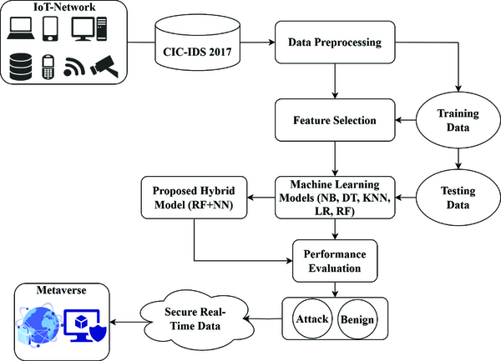

Figure 2. Proposed methodology.

The technique is a mainstream, powerful, Machine Learning (ML) pipeline, but aimed at the processing of network data, which would otherwise be generated by IoT devices in the Metaverse:
1. Data Collection (IoT Source): The given process will begin with the CIC-IDS 2017 Network Intrusion Dataset. The importance of this dataset is that it can record real-world network traffic, both benign and of the many types of attacks (DDoS, brute-force, infiltration) that might be initiated by hacked IoT devices within an MoT context.
2. Refining IoT Data (Data Preprocessing):
- Cleaning and Formatting: This is done by cleaning the raw data (network packet flows) to eliminate inconsistencies.
- Feature Scaling/Normalization: Each data attribute is scaled to make larger values (say, total packets sent) not dominate the learning process as compared to smaller, but important, data attributes (say, specific protocol flags). This is essential to heterogeneous IoT data.
- Feature Selection: In this step, the most applicable network characteristics (such as connection duration, failed logins, or protocol type) are selected that best forecasts an anomaly. The security features must be prioritized to minimize the complexity of the computations.
3. Model Implementation (Hybrid Core): The trained Hybrid RF-NN model is trained using the pre-processed data. This strategy tries to intertwine:
- Random Forest (RF): Superior in business when working with large volumes of data and finding significant features in a short period.
- Neural Network (NN): More capable of identifying non-linear and complex relationships and patterns in the data, which is vital in identifying advanced and dynamic attacks.
4. Assessment and Comparison (Validation):
- Testing: The trained hybrid model is tested on an unknown section of the data.
- Metrics: Performance is measured with the help of typical security measures: Accuracy, Precision, Recall, and F1-score. (The paper boasts of 99.99% accuracy at this stage).
- Comparison: The performance of the hybrid model is directly compared with a number of the single-classifier models (Decision Tree, Naive Bayes, KNN, etc.) to substantiate the selection of the hybrid model.

Although the suggested methodology is a good move towards network security, yet, its emphasis serves to reveal and solidify the security gaps underlying the IoT-Metaverse:
- Simulated Environment Gap: An external dataset (CIC-IDS 2017) is a methodological weakness that makes use of a standard dataset. There is no traffic in this dataset that is directly caused by XR headsets, haptic devices, or digital twin synchronizations, which are unique to the MoT. Thus, the fact that the model is highly accurate is confirmed with the traditional IT attacks, not the emerging threats of the Metaverse.
- Computational/Edge Gap: There is no complexity or resource analysis in the methodology. Hybrid RF-NN model is costly to run and train. This exclusion indicates the resource limitation gap, in that it does not verify whether this solution is usable to be deployed on the low-power Edge Layer devices (as envisioned in the figure).
- Gap in Data Integrity: The methodology presupposes that the input data will be network flows. It does not involve any steps on source authentication or the data trust verification on the IoT sensors themselves. The whole system remains susceptible to the False Data Injection (FDI) attack when an attacker transmits a large amount of logically correct and physically incorrect data that does not necessarily exist as a network anomaly.

A review of systematized literature on Metaverse cybersecurity identifies AI-powered IDS, privacy-saving structures and scalable identity management, and reveals quantum-enhanced protection (Al-Tameemi et al., 2025).
The main concerns that the literature review brings to light are:
The development of the Internet of Things (IoT) has radically increased the attack surface of the digital infrastructure. By being implemented in the Metaverse (MoT), the physical and virtual spaces get more interconnected, which exacerbates security risks. Furthermore, The Metaverse stores massive amounts of extremely sensitive personal data, such as biometric and behavioral data (which is often recorded by the IoT/XR devices) and, therefore, its handling, security, and privacy have become significant concerns. Finally, the immersive environment presents new cybercrime, identity theft, and digital fraud of a user of its digital property (NFTs, assets) and decentralized identity.
The review specifies and examines four broad set of strategic approaches that have been proposed in the literature: AI-based Secure Models is Required to detect and predict security to counter the complex, evolving threats and challenges that traditional approaches do not identify, Blockchain and Zero-Trust Provides decentralization, transparency, and is essential to establishing a transaction and provide decentralized identity (DID).

To identify some gaps on the suggested solutions:
The sheer quantity of biometric and behavioral information obtained in the Metaverse (via XR and IoT peripherals) is a significant privacy risk. The information is extremely sensitive and, once damaged, it cannot be reversed and have irreparable effects on the real-life identity of the user. Practical models that directly deal with the security issues that come with the integration of Metaverse and IoT using biometric data are lacking. This cannot be adequately covered using traditional measures. The suggested security solutions (such as decentralized identity management and adaptive intrusion detection) cast doubt on the implementation and scalability in reality because of the broad range of devices and applications. Research interest on the area of standardization is required especially on specific areas of application such as smart healthcare systems within the environment of Metavarsity to deal with the pressing privacy issues prior to mass adoption. The study is too dependent on theoretical explanations that sound well but fail miserably when it comes to practical applications in real-life situations, making them useless in dealing with real issues of security. Future studies should address the application of practical security models, considering the challenges of the IoT integration that exist at the ground level, including the resource limitations of edge devices and the need to undertake cybersecurity training with more extensive and real-world samples of participants. Essentially, though the literature suggests the application of AI and Blockchain to secure the Metaverse, the review highlights that the actual vulnerability is at the unstandardized, limited, and data-intensive IoT sensor layer, which is hard to protect with solutions with high computation requirements.

A multi layered security structure focuses on trusted infrastructure of the cloud networks, secure smart terminals, decentralized data/identity with blockchain, privacy preserving computing, and parallel twin network named ParaDefender (Li et al., 2023) The authors suggest adopting a concept of system security technology as a framework to build an all-encompassing Metaverse security protection solution on several levels of the infrastructure. The framework of the solution is organized in different perspectives: IoT Level To protect the endpoints and hardware gadgets that act as the entry points (VR/AR headsets, IoT sensors). Network Level to be used in securing communication (5G, network slicing) to ensure low-latency and integrity of data transmission. Cloud/Computing Level to safeguard the large size of data storage and the computing power required to execute the virtual environment. Digital Assets Tier of Securing NFTs, virtual currencies, and user-generated content (UGC).
Although the paper does manage to pinpoint the IoT layer as one of the weaknesses, the solution outline is often left at a very high, theoretical stage with numerous technical gaps still unaddressed: The core issue here is that when devices are produced initially there are no security concerns made and this can never be completely addressed by their network-level security. The solution has not specified a mechanism to check the reliability and integrity of the data source itself (the physical sensor) prior to it transferring its data. This will be very important in differentiating authentic sensor data and forgery. Addressing the issue of providing the weak IoT computing power as an abstract enables a weakness to be resolved in that direction, but further introduces the possibility of a Single Point of Failure (SPoF) or a centralized attack target in the management node/edge gateway, which undermines the decentralized approach of the Metaverse security efforts.

A related deep learning based IDS, Metaverse IDS, uses KPCA to reduce features and a CNN classifier, with 99.8% accuracy, 100% precision and a low false negative rate of 0.2% on ToN IoT and BoT IoT datasets (Gaber et al., 2023).
The article concerns the security risk of the intersection of the Metaverse and IoT, the issue of developing the high-performance IDS that can ensure the security in this data-intensive and complicated environment:
- Computational Issue: The interactive aspect of the Metaverse creates "large volumes of data" because of which makes the process of creating an effective IDS more difficult.
- Security Stakes: IoT networks have been integrated, so now cyberattacks can compromise the real and Virtual worlds, and solutions must not only be accurate but have low False Negative Rates (FNR) (failing to detect a real attack) and False Positive Rates (FPR) (creating unwarranted notifications).
- Absence of Appropriate IDS: Standard and single-user Deep Learning (DL) models fail to find a balance between high accuracy and low error rates on this dynamic and heterogeneous environment.
The article suggests a novel intrusion detector system, Metaverse-IDS, which is based on a 2-stage hybrid Deep Learning system:
Stage 1: Preprocessing and Feature Extraction: Kernel Principal Component Analysis (KPCA) employed to process and obtain the most meaningful attack features of the vast amount of high-dimensional and complex network traffic data. KPCA is essential to minimize noise and dimension of varying data streams generated by various types of IoT devices preparing the data to be manageable at the next step.
Stage 2: Attack Recognition and Classification: The feature set obtained after the KPCA will be entered into the CNN, which is highly efficient in the process of classifying the traffic flow as normal or one of the 12 types of MoT-relevant attacks. The capability of CNN to detect various types of attacks in real-time simultaneously gives the high-speed and accuracy detection required in real time security of MoT.
The model was strictly tested with the help of BoT-IoT and ToN-IoT that are considered to be the most popular benchmark datasets including several specific attacks on IoT with 99.8 percent accuracy and below 0.2 False Negative Rate (FNR).

The following figure illustrates a two-level, sequential data pipeline that will be used to classify attacks with the right degree of accuracy:

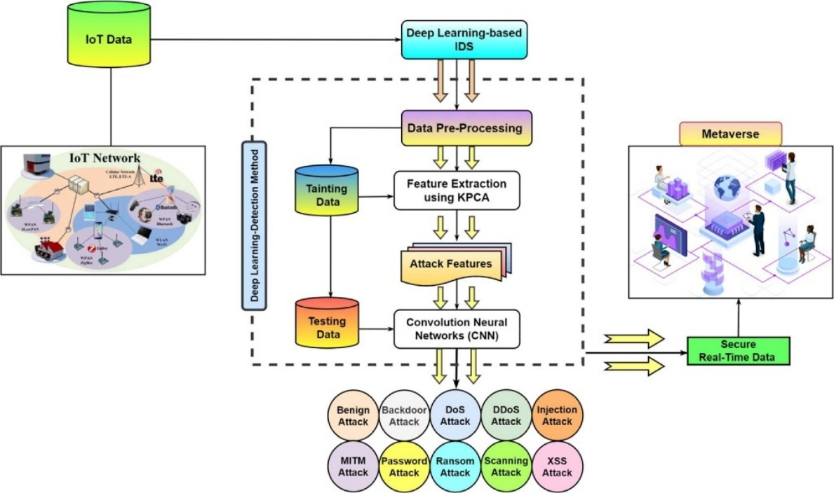

Figure 3. Architectural Framework

Stage A: Data ingestion and preprocessing (The IoT Source).
  - Input Data: This is initiated by the IoT Data (denoted by all the different devices such as sensors, routers and the different communication standards such as cellular, Bluetooth, WiMAX) that comes about as a result of the IoT Network.
  - Data Pre-Processing: This is an essential initial step that is necessary to prepare the raw network traffic data (probably in the form of numbers or transforming it into nominal features) to feed into the deep learning model.
  - Training/Testing Data: The data is divided into Training Data (to be used to train and validate) and Testing Data (to be used to measure the performance), which is a common practice in machine learning.

Stage B: Feature Engineering and Classification (The IDS Core)
- The KPCA Kernel Principal Component Analysis (KPCA) is applied to perform dimensionality reduction and obtain the most relevant, non-linear Attack Features in high-dimensional data. This is the system to make the data manageable and eliminate noise in the heterogeneous IoT traffic.
- Convolution Neural Networks (CNN): The features obtained are inputted into the CNN, the fundamental classification network. CNNs are very efficient to locate the spatial pattern of data.
- Output & Mitigation: CNN sorts the input into a single category of 12 distinct attack types (e.g., DoS, DDoS, Ransom Attack, MITM Attack, etc.) or Benign traffic. Attacks identified cause the relaying of Secure Real-Time Data to the Metaverse as malicious flows are blocked or prevented.

Though it has an advanced hybrid architecture, the figure itself graphically strengthens the unresolved security gaps that may be the most problematic concerning the IoT layer: The operational mechanism of the whole system is triggered by the network traffic data (packet flows, meta-data) being the only input. Deep CNNs and in particular those that operate in real-time, need substantial amounts of computational power (CPU, GPU, memory). General devices and protocols are represented in the IoT Network circle as shown in the figure. The approach is based on the training of labelled attack data.
To sum up, the Metaverse-IDS is an IDS solution that offers a high level of accuracy to secure the communication of the MoT network against a wide range of existing cyberattacks. Nevertheless, its performance does not go as far as it fails to solve the resource constraints at the edge and the crucial problem of maintaining trusted data input directly by the vulnerable terminals on the IoT side.

The literature review reveals that even with more advanced solutions (AI, Blockchain, Zero-Trust) being suggested to the Metaverse, their implementation is disastrously hampered by the underlying security vulnerabilities of the underlying Internet of Things (IoT) infrastructure.

1. The Main Issue: The Insecure-by-Design IoT Terminal.
This is the most critical and frequent point of failure that is found throughout the literature:
  - Absence of Hardware Security-by-Design: Articles indicate specifically that numerous AR/VR and general IoT gadgets do not take security into account during the initial stages of their creation (e.g. default passwords, weak firmware). This renders the terminal device the weakest point of entry to the whole Metaverse ecosystem.
- Resource Constraint Gap (The Deployment Barrier): Sophisticated security solutions (such as the deep learning models in Metaverse-IDS or DRL-GAN) are computationally expensive (large CPU, memory, and power consumption). This renders them unfeasible to be executed directly on the low power and resource-constrained IoT microcontrollers which comprise the overwhelming majority of MoT devices. This solution is frequently directed off to the Cloud/Fog layer, and the device itself is not secured anymore.
- Heterogeneity and Standardization: due to no standardized security standards and the sheer variety of IoT devices (different protocols, hardware, and APIs) it is difficult to implement any form of uniform, high level security.

2. Inconsistencies in Architecture and Data Integrity.
The system architecture of the solutions does not cover the integrity of the data stream of the compromised IoT source:
- The Data Integrity / False Data Injection (FDI) Gap: Intrusion Detection Systems (IDS) which include the advanced Metaverse-IDS are mostly designed to examine abnormalities in network traffic. They perform well in identifying such attacks as DDoS or scanning. They are however ineffective in determining whether the data payload is true or not. In case an attacker hacks a sensor to transmit them a maliciously false reading that will look normal in its network format (FDI), the IDS will probably not identify the integrity violation.
  - Centralization in Decentralization: The MoT would like to implement ZTA or Blockchain-based identity management, but the reality that traffic and offloading of computations necessitates the addition of a centralized element (a management node or Cloud/Fog server) is introduced. This re-introduces a Single Point of Failure (SPoF) which the architecture was meant to remove.

3. The Privacy and Identity Gap
The sensitive information of the IoT devices poses unique threats to the user digital and physical self:
- VR/AR and haptic sensors: Massive data collections on biometrics and behavioral variables (gaze, gait, voice, physiological state) are collected in real-time through VR/AR sensors to perform constant authentication and immersion. In case this very sensitive information gets leaked, this exposes the real life identity of a user in an irreversible manner.
- Cost of Privacy: (Paper 6) The most advanced privacy-sensitive methods (such as ML-based targeted protection) are computationally costly or not reliable. This presents a painful trade-off between the privacy/security of the information and the low latency real-time immersion of the Metaverse that is anticipated.

- Proposed solution

2.0 Problem Statement

The existing IoT systems tend to have severe security, privacy, and scalability weaknesses, particularly when they are employed with very interactive Metaverse environments. The current solutions are unable to secure decentralized device endpoints, facilitate real-time threat detection, and avoid privacy breaches when data is aggregated. These are especially acute in systems of smart cities, digital healthcare, and AR/VR-based public services, in which a data breach can have serious social and economic implications.
Although AI-based Intrusion Detection Systems look promising, the centralized data models disclose sensitive data, which provokes regulatory and inefficient use of resources. The task is then to come up with an IoT architecture that: Day one of the adaptive, resilient security and real-time defense. Ensures privacy and integrity of data. Favors dynamic distributed environments and cross-industry relationships.

2.1 Proposed IoT Solution

2.1.0 Concept Overview

The SFZ EA architecture establishes a zero-trust IoT security system in which every connected IoT device on the Metaverse edge authentically verifies its identity cryptographically, trains on a learning system (with the federated learning system), and communicates via blockchain anchored transactions. This facilitates dynamic, privacy protecting cybersecurity.

2.1.1 Implementation and Entrepreneurial Impact

1. Physical and Edge Layer - Zero Trust Endpoint Design.
- Fit IoT hardware devices (e.g. AR/VR wearables, sensor, or cameras) with a Trusted Platform Module (TPM) in a secure hardware selection.
- Apply a Zero trust overlay network (ZTON) such as OpenZiti to encrypt all communications between devices and services (Ameer et al., 2024).
- Deploy Edge Routers and Controllers (e.g. Ziti Edge Routers) as Docker containers to enforce: Policy of identity-based access, Encrypted traffic routing, Constant monitoring (no implicit trust).

This stage offers an Edge Security as a Service (ESaaS) model that can be commercialized by the startups on behalf of smart cities or AR infrastructure operators.
SDG Goal Alignment: Goal 11: Sustainable Cities & Communities - boosts safe and smart cities. Goal 16: Peace, Justice and Strong Institutions- enhances data trust and transparency.

2. Federated Learning Implementation Edge Intelligence.
- Run Federated Learning customers at edge gateways to locally train behavioral and environmental IoT data. (Chen et al., 2023)
- Every FL client calculates the gradients of models using the local data (the data is not shared).
- Secure federated aggregator, which is secured with the help of Secure Multi Party Computation (SMPC), gathers encrypted updates of all the nodes.
- Anomaly detection is done using lightweight models like a CNN-BiLSTM fusion (in " A Federated Learning Based Zero Trust Intrusion Detection Framework, 2024).

This stage reduces cloud dependency; facilitates subscription based federated model marketplaces in which smart industries (manufacturing, logistics, healthcare) participate in sharing security gains without data disclosure.
Supports Goal 9: Industry, Innovation, and Infrastructure, resilient digital infrastructure.

- Blockchain Layer - Trust and Traceability Decentralization.
- Combine two level blockchain consensus to achieve the recording of model updates and change of policy in a transparent way (Ren et al., 2024).
- Use FLCoin (committee based blockchain federated system) to offer low latency verification (latency of <3 s).
- Smart contracts manage: Device identity proofs, rewards based on a federated learning (token-based rewards), checking access and data lineage.

This stage turns security into a token economy of trust, in which certified IoT devices or models are rewarded with tokens in engaging in security enhancing mechanisms.

- Cloud and Application Layer - Adaptive Orchestration
- Test the input federated updates with AI Orchestration Agents.
- Implement dynamic trust calibration, which changes device privileges depending on performance and anomaly record. (Li eat al., 2025).
- enable free visualization of IoT Metaverse interactions through a cloud dashboard that facilitates explainable AI (XAI) (visualizing device behavior, attack patterns, trust scores).
This stage offers a government or energy grid or gaming metaversion subscription platform and Sell "Security Twin" , a metaverse digital twin simulator to simulate threats and verify their safety before actual deployment.

2.1.2 The system architecture diagram

The figure below illustrates the proposed solution:

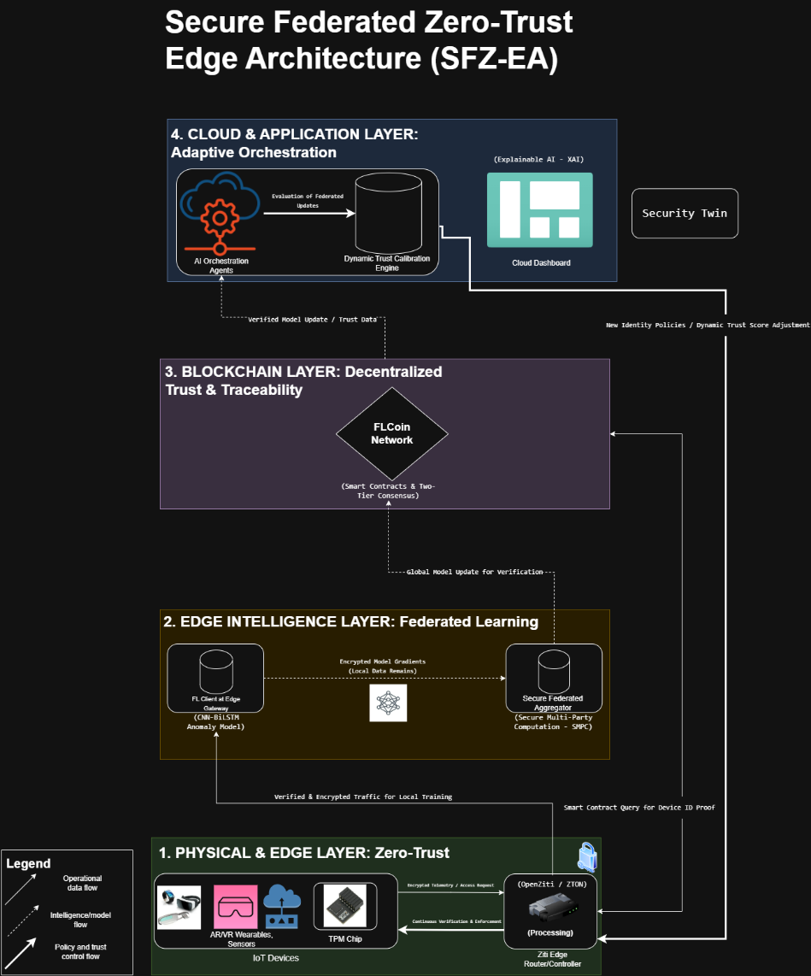

Figure 4. SFZ-EA Architecture

Layer 1: - IoT devices are secured with TPM chips. The chip stores a unique cryptographic key that proves the device's identity to the network.
  - Ziti Edge Router/Controller - This software module stands at the border; it builds an encrypted tunnel network (ZTON). Each packet that asks for a service must first present a valid identity token, otherwise the router drops it.
Layer 2: - Federated Learning (FL) Client, a small agent on the gateway trains a CNN-BiLSTM model locally. The raw logs stay on the gateway; only numeric weight changes leave the box.
  - Secure Federated Aggregator, a backend service gathers the weight sets from every gateway. With SMPC, it adds the vectors under encryption, so no party sees another's numbers. The sum becomes the next global model.
Layer 3: - FLCoin Network, a distributed ledger. A two-tier consensus protocol decides which new block to append. Each block records a hash of the global model and any policy change giving every node the same reference history.
  - Smart contracts perform three tasks: Check that a device's TPM quote matches an enrolled key, confirm that the aggregated weights come from the registered aggregator, transfer token credits to devices that supplied valid gradients.
Layer 4: - AI Orchestration Agents, pieces of code in the cloud collect each new model that passed the Layer 3 blockchain check. They read the model, compute a fresh Trust Score for every device by combining its past actions plus any anomalies it triggered.
  - Dynamic Trust Calibration Engine, another program turns the numeric Trust Score into a concrete rule list, who may open which port, who must re-authenticate and so on.
  - Cloud Dashboard, a web page, shows the current Trust Score of each unit but also a short, plain language reason for every change. Operators watch the page and see why a device lost or gained rights.

The operational data flow: raw data leaves the IoT devices, passing through the ziti edge router and reaches the FL client that then feeds this data into its local training task.
The model flow: a Federated Learning circuit moves the trained knowledge uphill. The FL Client sends its gradient update to the Secure Aggregator, the Aggregator forwards the merged result to the FLCoin Network, the blockchain notarizes the update. Finally, the AI Orchestration Agents accept it.
Policy flow: A zero trust enforcement circuit carries new rules downhill. The AI Orchestration Agents dispatch the updated Trust Score to the Dynamic Trust Calibration Engine , the Engine emits a policy file, the Ziti Edge Router loads the file or immediately tightens or relaxes each device's reach.

2.1.3 Industry Application
The system suits smart cities, online healthcare and 3-D virtual worlds because it lets people and devices exchange data instantly while security rules stay in force.
In a healthcare use case, a patient wears lightweight AR goggles that read heart rate plus blood oxygen. The goggles send the numbers straight to the SFZ EA network. No outside party stores or controls the data and personal details stay hidden.

2.1.4 Unique Value Proposition
- Adaptive trust intelligence merges zero trust architecture with federated learning. Lets smart devices prove reliability in real time while evolving their trustworthiness autonomously.
- Energy efficient security via decentralization reduces network strain and cuts processing demands, slashing CPU load by 10-15 percent versus traditional systems.
- Data sovereignty remains uncompromised. Edge computing preserves privacy, blockchain ensures tamperproof logs for traceability without exposure.
- A versatile marketplace emerges, turning threat insights into tradable commodities, accessible across sectors.

2.1.5 Scope of the System

Included:
- Safeguarding IoT-to-metaverse connections, endpoints, secure messaging pathways.
- Federated learning for distributed model refinement, immutable recording of access rules and confidence metrics via blockchain.
- AI-powered, self-adjusting zero trust protocols spanning multilayered IoT ecosystems.

Excluded:
- Hardware production satndards.
- Legacy IoT systems missing trusted platform modules or embedded security.
- Policing metaverse content unrelated to safety, monitoring nonthreatening user actions.

2.1.6 Functional and Non-functional requirements

Functional Requirements:

Requirement | Description
Secure Device Identity | Every IoT device holds a unique cryptographic key stored in a blockchain linked TPM chip. The chip proves the device identity and blocks any attempt to alter the key or the firmware.
Zero Trust Access Control | Every message that travels through the network must carry fresh proof of identity. Devices plus users never trust one another by default, they verify each partner for every single exchange.
Federated Learning Node | Edge gateways collect encrypted sensor readings, decrypt them only inside a secure enclave, train a local security model and share only the numeric model weights with neighbors. The shared weights let many gateways build a common defense without exposing the original data.
Intrusion  Detection System | A lightweight AI engine that combines a convolutional network with a bidirectional LSTM runs on each gateway. The engine scores every new packet. If the score crosses a fixed threshold, the gateway drops or blocks the traffic within milliseconds
Secure Data Flow | Payloads stay encrypted while they move from the device to the edge node but also onward to the cloud. The only information that leaves the edge is a set of anonymized statistics or model parameters that reveal nothing about individual users or events.
Blockchain Audit Trail | All security actions and model updates are recorded in a tamper proof log to support audits and meet compliance rules.
Smart Contract Management | The platform applies fixed rules that assign a trust grade to each device, set what each device is allowed to do plus give small rewards for correct federated participation.
Explainable AI Dashboard | Stakeholders receive dashboards that display current trust scores, live graphs of network activity and short statements that explain every access decision.
Secure Policy Updates | New security policies are created in the cloud but also sent to every edge node - each node enforces the policy without further human action.
Privacy-Preserving Aggregation | Secure Multi-Party Computation keeps the raw data of each participant hidden while the nodes compute the joint model update.

Non-functional Requirements:

Requirement | Description
Scalability | The architecture will support thousands of devices without central bottlenecks.
Resilience | Adaptive real-time response to network threats and outages.
Energy Efficiency | Localized processing reduces cloud overhead and device energy use.
Regulatory Compliance | Blockchain auditability and privacy frameworks meet current global data laws.
Interoperability | Modular API design fits diverse IoT hardware standards and Metaverse protocols.
Latency | Edge decisions and threat responses take place in milliseconds.
Availability | Redundant gateways/cloud nodes guarantee constant uptime.
Data Integrity | Tamper-resistant blockchain storage keeps the record accurate.
Usability | Dashboards and controls designed for non-technical stakeholders.
Extensibility | The system allows for the addition of AI, industry, and Metaverse integrations in the future.

- Conclusion

SFZ-EA facilitates business opportunities in digital healthcare, smart cities, and various other sectors by delivering IoT and Metaverse ecosystems that feature adaptive, resilient, and privacy-focused security. This innovative approach provides sustainable and future-oriented digital infrastructure, distinguishing itself in the market through real-time federated intelligence, blockchain trust anchoring, and a clear alignment with the Sustainable Development Goals (SDGs).

- Video Pitch

https://youtu.be/nTLFcQLF8TY?si=NBj0DhBwL_LWbuYm

5) References list
1. Cheng, R., Chen, S. and Han, B. (2023). Towards Zero-trust Security for the Metaverse. [online] arXiv.org. Available at: https://arxiv.org/abs/2302.08885.
‌2. Gaber, T., Joseph Bamidele Awotunde, Torky, M., Sunday Adeola Ajagbe, Hammoudeh, M. and Li, W. (2023). Metaverse-IDS: Deep Learning-based Intrusion Detection System for Metaverse-IoT Networks. Internet of Things, 24, pp.100977–100977. doi:https://doi.org/10.1016/j.iot.2023.100977.
3. Petar Radanliev (2024). Integrated cybersecurity for metaverse systems operating with artificial intelligence, blockchains, and cloud computing. Frontiers in blockchain, 7. doi:https://doi.org/10.3389/fbloc.2024.1359130.
4. Vashisht, S., Rani, S. and Shabaz, M. (2025). Towards a secure Metaverse: Leveraging hybrid model for IoT anomaly detection. PLOS ONE, 20(4), p.e0321224. doi:https://doi.org/10.1371/journal.pone.0321224.
5. Hasan Ali Al-Tameemi, Ghadeer Ghazi Shayea, Mishall Al-Zubaidie, Khaleel, Y.L., Habeeb, M.A., Noor, Homod, R.Z., Aljanabi, M., O.S Albahri, Alamoodi, A.H., Mijwil, M.M., Fadhel, M.A., Sharaf, I.M., Yaseen, M.G., Ali, A.H., Mahmoud, U.S., Mohammed, S.M. and Albahri, A.S. (2025). A Systematic Review of Metaverse Cybersecurity: Frameworks, Challenges, and Strategic Approaches in a Quantum-Driven Era. Mesopotamian Journal of CyberSecurity, [online] 5(2), pp.770–803. doi:https://doi.org/10.58496/MJCS/2025/045.
6. Li, A., Yao, X., Gu, H., Zhang, Y. and Chang, Y. (2023). Towards building a firm metaverse security base. Security and Safety. doi:https://doi.org/10.1051/sands/2023005.
7. Ali, T., Al-Khalidi, M., Al-Zaidi, R., Eleyan, A. and Ur Rehman, M.A. (2024). Securing the Metaverse: A Deep Reinforcement Learning and Generative Adversarial Network Approach to Intrusion Detection. 2024 IEEE International Conference on Communications Workshops (ICC Workshops), [online] pp.263–268. doi:https://doi.org/10.1109/iccworkshops59551.2024.10615630.
‌8. Liu, K., Zheng, T., Zhou, T., Liu, C., Liu, F. and Cai, Z. (2024). The Security and Privacy Concerns on Metaverse. Communications in computer and information science, pp.287–305. doi:https://doi.org/10.1007/978-981-97-1332-5_23.
‌9. Li, K., Cui, Y., Li, W., Lv, T., Yuan, X., Li, S., Ni, W., Simsek, M. and Dressler, F. (2022). When Internet of Things meets Metaverse: Convergence of Physical and Cyber Worlds. IEEE Internet of Things Journal, pp.1–1. doi:https://doi.org/10.1109/jiot.2022.3232845.
‌10. Veeraiah, V., P, G., Ahamad, S., Talukdar, S.B., Gupta, A. and Talukdar, V. (2022). Enhancement of Meta Verse Capabilities by IoT Integration. 2022 2nd International Conference on Advance Computing and Innovative Technologies in Engineering (ICACITE). doi:https://doi.org/10.1109/icacite53722.2022.9823766.
‌11. Singh, J., Singh, P., Kaur, R., Kaur, A. and Mustapha Hedabou (2025). Privacy and Security in the Metaverse: Trends, Challenges, and Future Directions. IEEE Access, [online] 13, pp.120209–120243. doi:https://doi.org/10.1109/access.2025.3587015.
‌12. Jusia Amanda Ginting, Irwan Sembiring, Putra, Y.R. and Marvelino, M. (2025). REVOLUTIONIZING DIGITAL TRUST: NETWORK INTRUSION DETECTION SYSTEMS FOR IDENTITY AND SECURITY ASSURANCE IN THE METAVERSE. Infotech Journal of Technology Information, [online] 11(1), pp.115–120. doi:https://doi.org/10.37365/jti.v11i1.381.
‌13. Saranya, A., Iyer, R., Maralapalle, V. and Wagle, and S. (2025). Quantum computing and Metaverse security. Defending the Metaverse, pp.171–195. doi:https://doi.org/10.1201/9781003581659-9.
14.Ameer, S., Lopamudra Praharaj, Sandhu, R., Bhatt, S. and Gupta, M. (2024). ZTA-IoT: A Novel Architecture for Zero-Trust in IoT Systems and an Ensuing Usage Control Model. ACM Transactions on Privacy and Security. doi:https://doi.org/10.1145/3671147.
15. Azad, M.A., Abdullah, S., Arshad, J., Lallie, H. and Ahmed, Y.H. (2024). Verify and trust: A multidimensional survey of zero-trust security in the age of IoT. Internet of things, 27, pp.101227–101227. doi:https://doi.org/10.1016/j.iot.2024.101227.
16. Zanasi, C., Russo, S. and Colajanni, M. (2024). Flexible zero trust architecture for the cybersecurity of industrial IoT infrastructures. Ad Hoc Networks, 156, pp.103414–103414. doi:https://doi.org/10.1016/j.adhoc.2024.103414.
‌17. sah, D. kumar, Vahabi, M. and Fotouhi, H. (2025). Federated learning at the edge in Industrial Internet of Things: A review. Sustainable Computing: Informatics and Systems, [online] 46, p.101087. doi:https://doi.org/10.1016/j.suscom.2025.101087.
‌18. Ramadan, M.N.A., Ali, M.A.H., Khoo, S.Y. and Alkhedher, M. (2025). Federated learning and TinyML on IoT edge devices: Challenges, advances, and future directions. ICT Express. [online] doi:https://doi.org/10.1016/j.icte.2025.06.008.
‌19. Ren, Y., Wang, Z., Sharma, P.K., Alqahtani, F., Amr Tolba and Wang, J. (2025). Zero Trust Networks: Evolution and Application from Concept to Practice. Computers, materials & continua/Computers, materials & continua (Print), 0(0), pp.1–10. doi:https://doi.org/10.32604/cmc.2025.059170.
‌20. Nasser Nammas Albogami (2025). Intelligent deep federated learning model for enhancing security in internet of things enabled edge computing environment. Scientific Reports, [online] 15(1). doi:https://doi.org/10.1038/s41598-025-88163-5.
‌21. Rane, J., Kaya, Ö., Mallick, S.K. and Rane, N.L. (2024). Future Research Opportunities for Artificial Intelligence in Industry 4.0 and 5.0. Future Research Opportunities for Artificial Intelligence in Industry 4.0 and 5.0. [online] doi:https://doi.org/10.70593/978-81-981271-0-5.
22. Oredola, C. and Ashraf, A. (2024). A Systematic Mapping Study on SDN Controllers for Enhancing Security in IoT Networks. [online] arXiv.org. Available at: https://arxiv.org/abs/2408.01303.
‌23. Hassan, A., N Nizam-Uddin, Quddus, A., Rehman, A.U. and Hassan, S.R. (2024). Navigating IoT Security: Insights into Architecture, Key Security Features, Attacks, Current Challenges and AI-Driven Solutions Shaping the Future of Connectivity. Computers, Materials & Continua. [online] doi:https://doi.org/10.32604/cmc.2024.057877.
24. Al-Bahri, M., Alkishri, W., Ahmed, F.Y.H., Alshar’e, M. and Maskari, S.A. (2024). Enhancing IoT Network Security Through Digital Object Architecture-Based Approaches. Qubahan Academic Journal, [online] 4(1), pp.224–239. doi:https://doi.org/10.48161/qaj.v4n1a413.
25. Rehman, A., Awan, K.A., Al-Rasheed, A., Ara, A., Alruwaili, F.F., Al-Otaibi, S. and Saba, T. (2025). A novel hybrid fuzzy logic and federated learning framework for enhancing cybersecurity and fraud detection in IoT-enabled metaverse transactions. Egyptian Informatics Journal, [online] 30, p.100668. doi:https://doi.org/10.1016/j.eij.2025.100668.
26. Jokic, A., Zivkovic, M., Jovanovic, L., Mravik, M., Sarac, M., Simic, V., Khan, M.A. and Bacanin, N. (2025). A convolutional neural network-enhanced attack detection framework with explainable artificial intelligence for internet of things-based metaverse security. Engineering Applications of Artificial Intelligence, [online] 158, p.111358. doi:https://doi.org/10.1016/j.engappai.2025.111358.
27. Goyal, S., Rashid, Z.A.H., Ghobash, A., Habelalmateen, M.I., Meassar, A.-H. and Zaidan, D.T. (2024). An Integrated Framework for Detecting Attacks And Security using Software-Defined IOT (Metaverse). 2024 4th International Conference on Advance Computing and Innovative Technologies in Engineering (ICACITE), pp.635–638. doi:https://doi.org/10.1109/icacite60783.2024.10616939.
‌28. Taj, I. and Adnan, M. (2025). Quantum-Resistant Security Framework for Secure and Scalable IoT-enabled Metaverse Environments. IEEE Transactions on Consumer Electronics, pp.1–1. doi:https://doi.org/10.1109/tce.2025.3558268.
29. Darji, K., Trivedi, C., Gupta, R., Fenil Ramoliya, Sudeep Tanwar and Agrawal, S. (2025). Securing IoT-enabled Metaverse with Authentication and Threat Classification Framework Using DL. [online] pp.104–109. doi:https://doi.org/10.1109/isacc65211.2025.10969244.
‌30. Antonijevic, M., Zivkovic, M., Djuric Jovicic, M., Nikolic, B., Perisic, J., Milovanovic, M., Jovanovic, L., Abdel-Salam, M. and Bacanin, N. (2025). Intrusion detection in metaverse environment internet of things systems by metaheuristics tuned two level framework. Scientific Reports, 15(1). doi:https://doi.org/10.1038/s41598-025-88135-9.
‌31. Arxiv.org. (2021). Zero-Trust Foundation Models: A New Paradigm for Secure and Collaborative Artificial Intelligence for Internet of Things. [online] Available at: https://arxiv.org/html/2505.23792v1.
‌32. Kang, J., Ye, D., Nie, J., Xiao, J., Deng, X., Wang, S., Xiong, Z., Yu, R. and Niyato, D. (2022). Blockchain-based Federated Learning for Industrial Metaverses: Incentive Scheme with Optimal AoI. [online] arXiv.org. Available at: https://arxiv.org/abs/2206.07384 [Accessed 3 Nov. 2025].
‌32. Ren, S., Kim, E. and Lee, C. (2024). A scalable blockchain-enabled federated learning architecture for edge computing. PLoS ONE, 19(8), pp.e0308991–e0308991. doi:https://doi.org/10.1371/journal.pone.0308991.
‌33. Danish Javeed, Muhammad Shahid Saeed, Adil, M., Kumar, P. and Alireza Jolfaei (2024). A federated learning-based zero trust intrusion detection system for Internet of Things. Ad hoc networks, pp.103540–103540. doi:https://doi.org/10.1016/j.adhoc.2024.103540.
‌34. Papakotoulas, A., Mylonas, T., Panagidi, K. and Hadjiefthymiades, S. (n.d.). OPTIMIZING IOT SECURITY VIA TPM INTEGRATION: AN ENERGY EFFICIENCY CASE STUDY FOR NODE AUTHENTICATION. [online] Available at: https://www.itu.int/dms_pub/itu-s/opb/jnl/S-JNL-VOL5.ISSUE1-2024-A06-PDF-E.pdf.
35. Faisal, M., Ali, I., Khan, M.S., Kim, S.M. and Kim, J. (2020). Establishment of Trust in Internet of Things by Integrating Trusted Platform Module: To Counter Cybersecurity Challenges. Complexity, 2020, pp.1–9. doi:https://doi.org/10.1155/2020/6612919.
‌36. Zamanian, M.K. (2024). A Comparative Study of AI Agent Orchestration Frameworks. [online] Available at: https://www.researchgate.net/publication/386083531_A_Comparative_Study_of_AI_Agent_Orchestration_Frameworks.
37. Alfadhil, M.J., Baydoun, A., Alazab, M., Rehman, H.U., Jaam, J.A. and Al-Maadeed, S.A.S.A. (2025). Enhancing federated learning for IoT-based anomaly detection: A reputation-based client selection approach. Alexandria Engineering Journal, [online] 130, pp.889–909. doi:https://doi.org/10.1016/j.aej.2025.09.019.
38.Ali, S., Abuhmed, T., El-Sappagh, S., Muhammad, K., Alonso-Moral, J.M., Confalonieri, R., Guidotti, R., Ser, J.D., Díaz-Rodríguez, N. and Herrera, F. (2023). Explainable Artificial Intelligence (XAI): What we know and what is left to attain Trustworthy Artificial Intelligence. Information Fusion, [online] 99(101805), p.101805. doi:https://doi.org/10.1016/j.inffus.2023.101805.
‌39. Alqahtani, H. and Abdullah, M. (2024). A Taxonomy of IDS in IoTs: ML Classifiers, Feature Selection Models, Datasets and Future Directions. International Journal of Advanced Computer Science and Applications, [online] 15(6). doi:https://doi.org/10.14569/ijacsa.2024.0150682.
‌40.Marusich, L.R., Files, B.T., Bancilhon, M., Rawal, J.C. and Raglin, A. (2025). Trust Calibration for Joint Human/AI Decision-Making in Dynamic and Uncertain Contexts. Lecture Notes in Computer Science, pp.106–120. doi:https://doi.org/10.1007/978-3-031-93412-4_6.
‌41. Naidu, D.J.S., Jain, U., S, S., Rao, K.B.V.B., Iqbal, S.M.U. and L, N. (2024). Dynamic Trust Management in IoT Networks using Reputation-Based Systems. 2024 International Conference on Distributed Systems, Computer Networks and Cybersecurity (ICDSCNC), [online] pp.1–6. doi:https://doi.org/10.1109/icdscnc62492.2024.10939325.
‌

‌

‌

‌

‌

‌

‌

‌

‌

‌

‌

‌

‌

‌

